Git-github-task
1.Create a GitHub account.
Step 1: set username
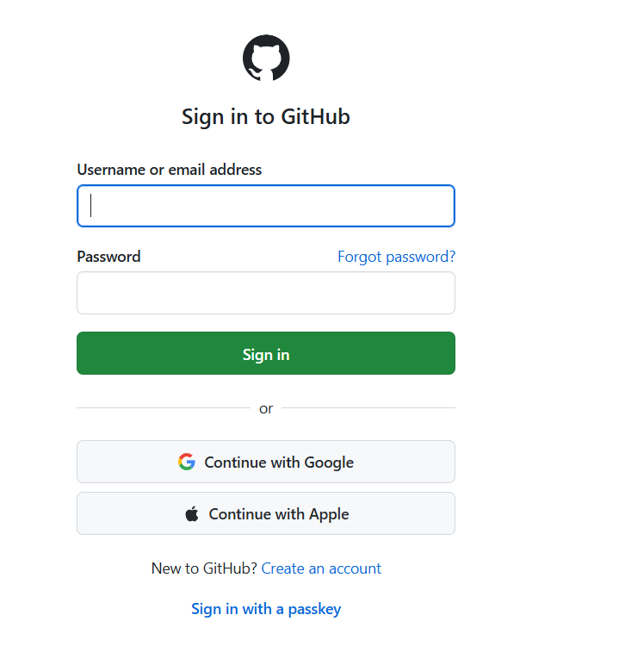
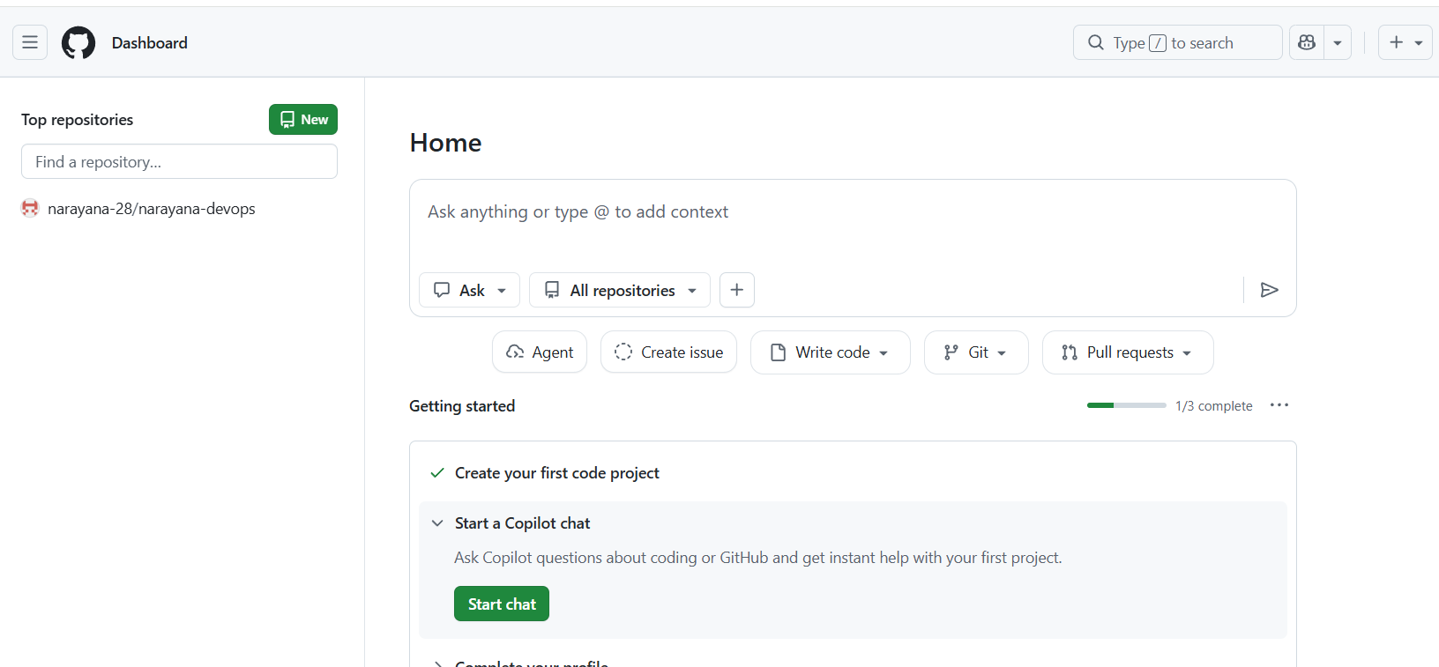
2.Set up MFA (Multi-Factor Authentication) for the GitHub account using a mobile app.
Step :1 Profile → Go to setting
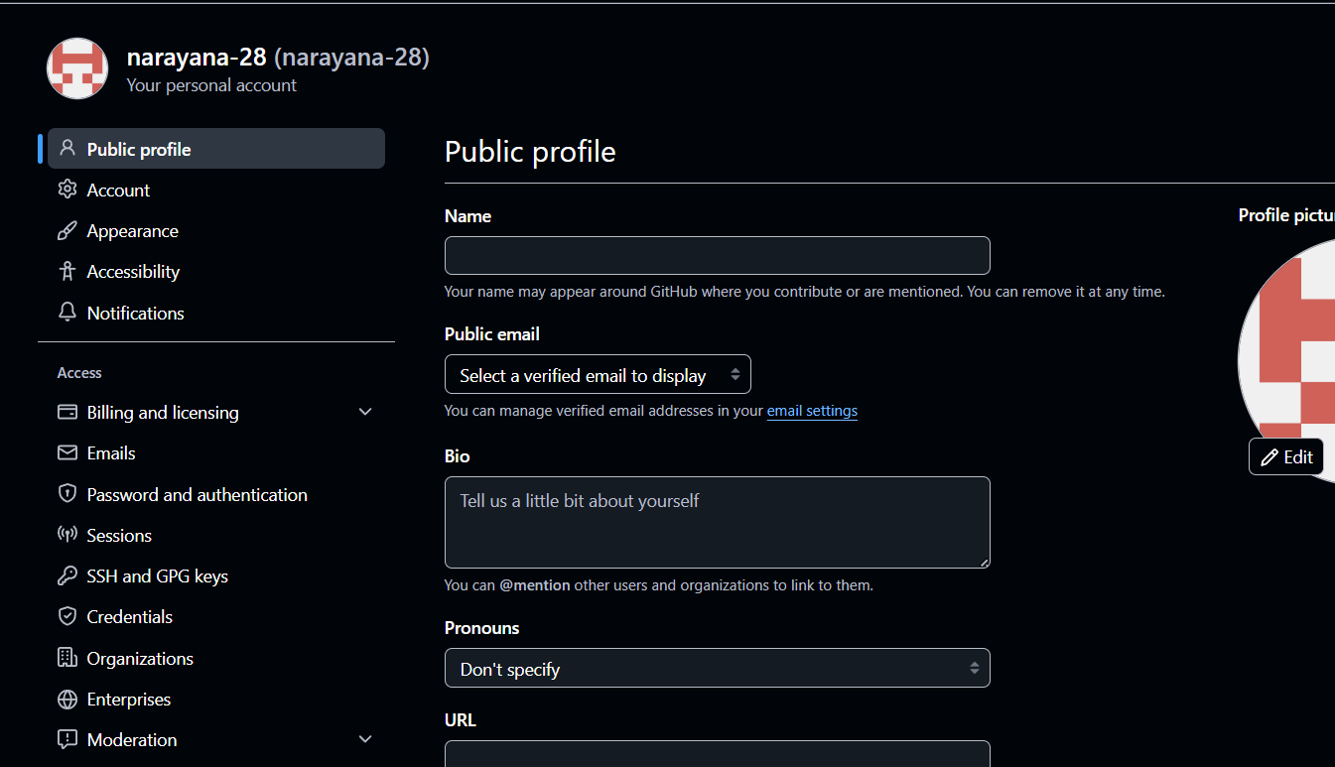
Step2: Go to Password and Authentication
1. In the left menu, click Password and authentication.
2. Scroll to Two-factor authentication.
3. Click Enable two-factor authentication.

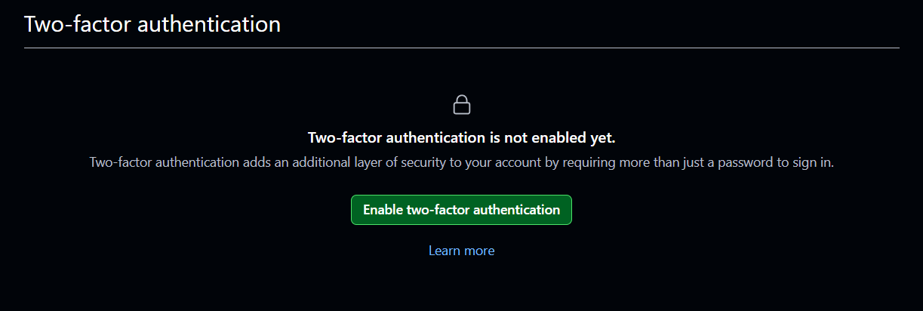

3.Execute all commands shown in the video.
1.Check weather git is already installed in your machine or not
Command – git –version
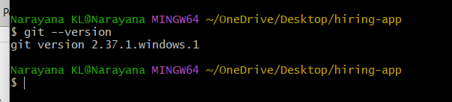
Git is already installed in your machine
If not install manually using your web browser.
2. created directory name : hiring-app and also created file Dockerfile
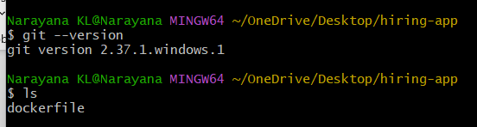

Step 3: check the changes
Command : git status
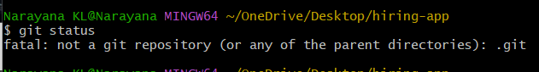

Step 4: track directory
Command : git init
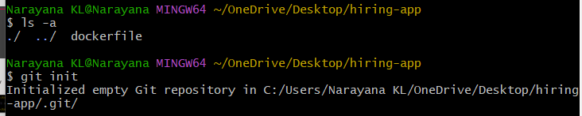
Command : ls -a
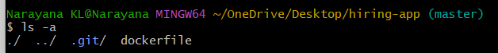
See configuration
cd .git/
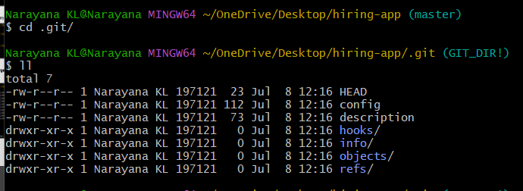

Check git status
Command : git status
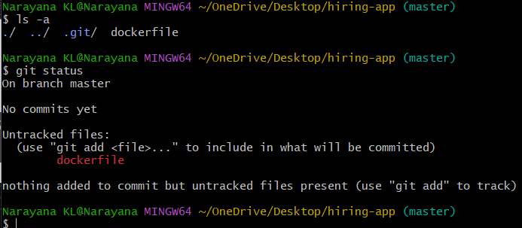
Create sample file narayana
Command : touch Narayana
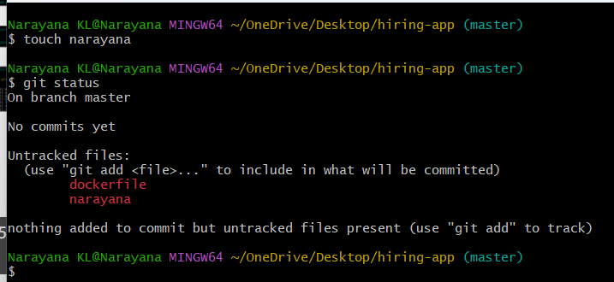
Delete file
Rm -rf .git/
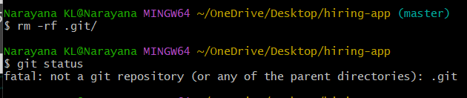
Again need to initialize git init
Command : git init
git status
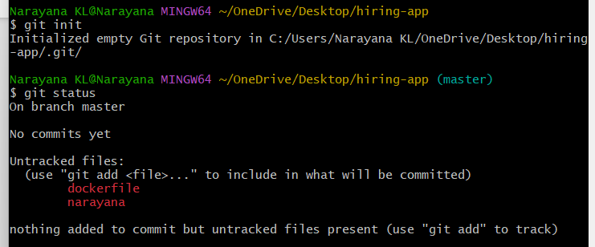

Now we need to check configure username and email
Command : git config –list
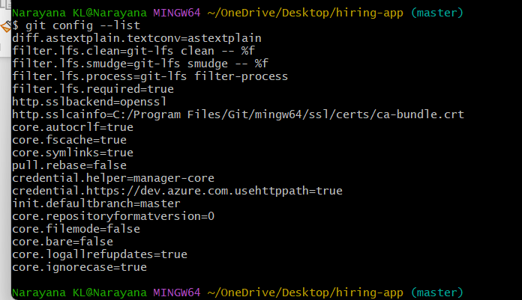
If you don’t see configuration of username and email need to configure
Note: without cofiguring username and email we can’t push file from local to central
Commands : git config --global user.name “narayana-28”

git config –global user.email “kadalakshminarayana@gmail.com”
git config –list
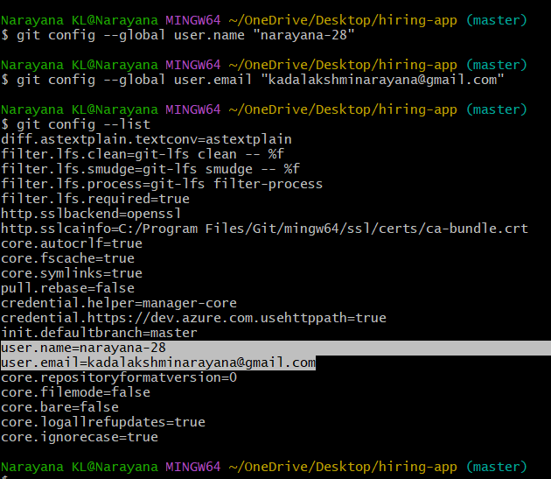
Push from local system to control repository
Step 1: need to move file from untracking to tracking area
Command : git add filenames

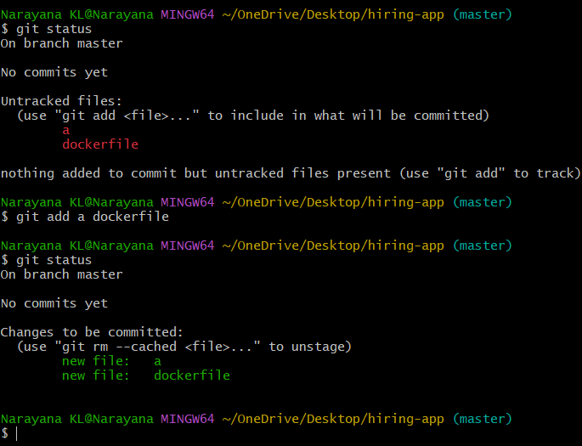

How to push all file at once instead of entering manually
Create sample files b c d e f g
Command : touch b c d e f g
Command : ls
Check status of untrack files
Command : git status
Command : git add .
. dot means all the files
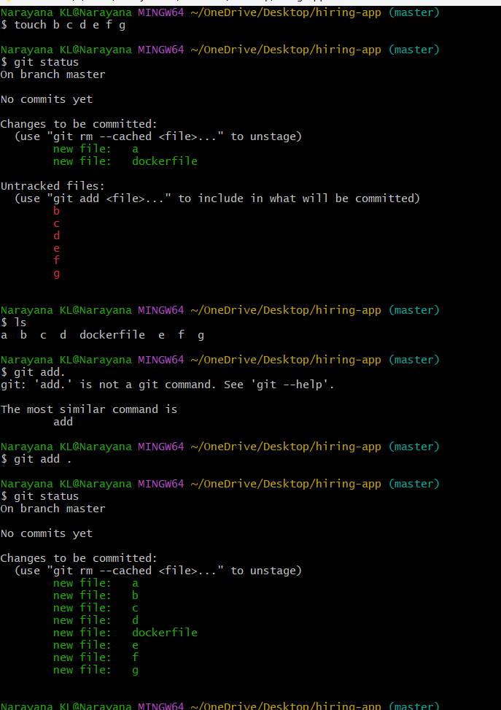
Commit changes : it will store copy in the machine or it will track changes
Command : git commit -m
-m -----mesage or comment
After commit check status
git status
it shows no commit pending
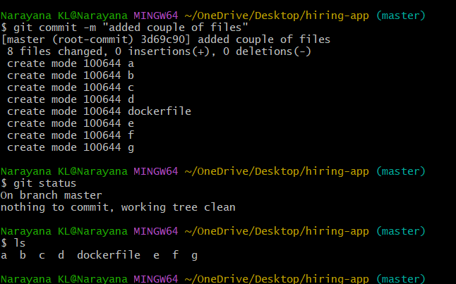
To check commit number or id or if want to check change
Command : git log
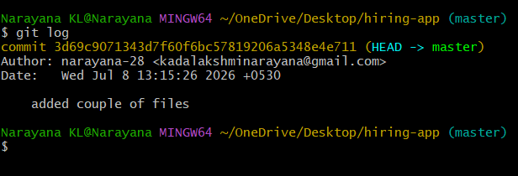

Now we want to store all files in central repository (github)
Step : 1 go to github and create repository
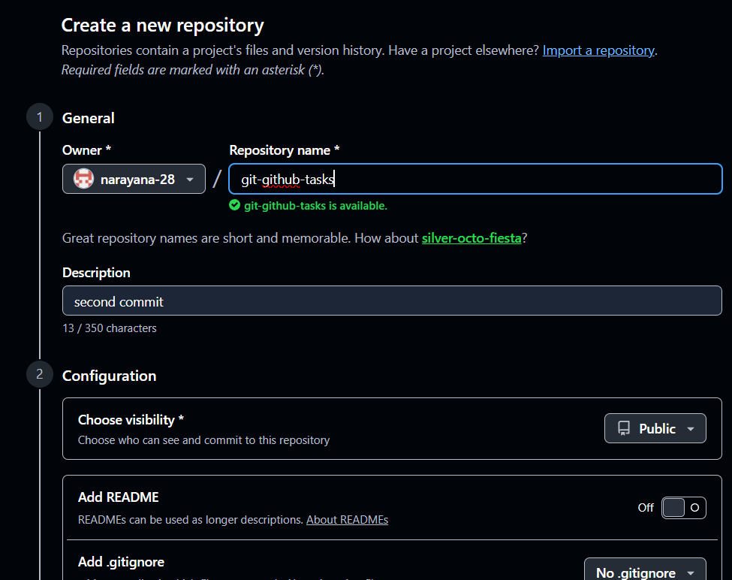
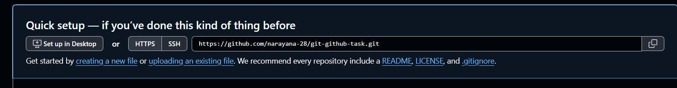
http = port number 443 there will be some authentication issues that we need add username and password everytime where as in
ssh =port number 22 we no need to add username and password because this will work on ssh configuration that we created ssh keygen that we enabled it so it wont’t ask username and password everytime.

Step 2: in terminal -check if any address configure or not
Command : git remote -v
Step 3: add SSH url (copy from gitbut and paste)
Command : git remote add origin
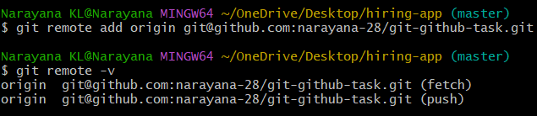

Before push we need to have connectivity we need ssh key
Generate SSH key
Command : ssh-keygen
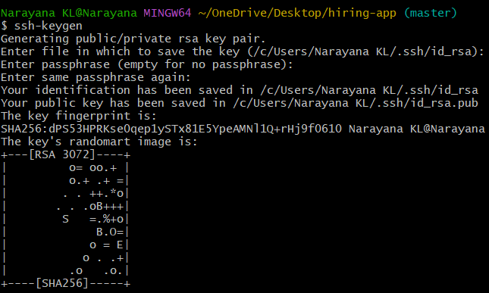
Read ssh key
Copy public key and go to git tub
command : cat /c/Users/Narayana KL/.ssh/id_rsa.pub
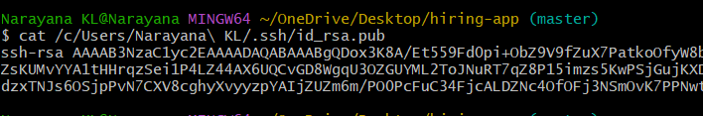
Got to git hub profile ---settings--ssh and gpg keys
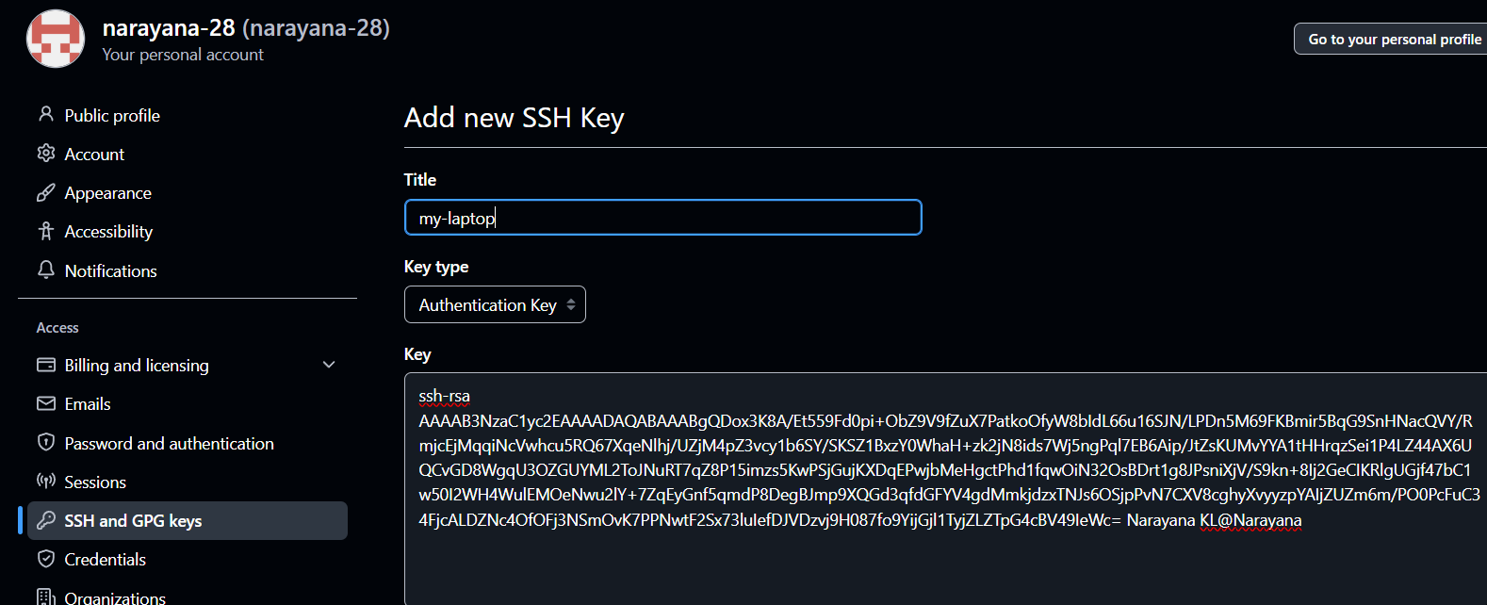
Copy ssh key terminal and paste in github
Click on add SSH key
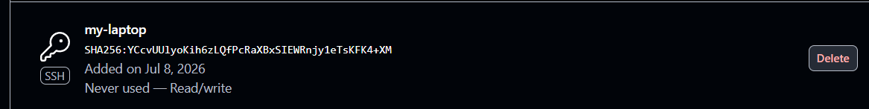
Now we can push
Command : git push -u origin main
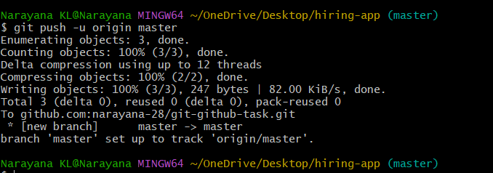
Go to gihub and refresh page
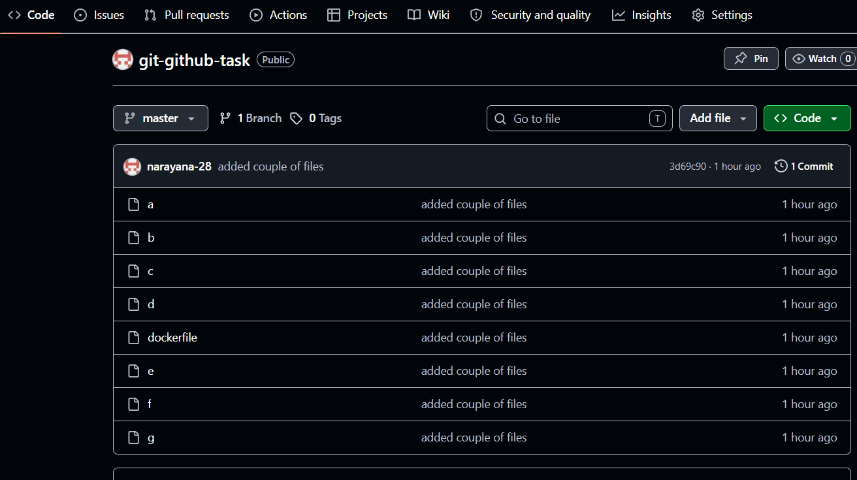
Scenario 1: If a file is deleted from the local system, it will not be deleted from the central
repository until the changes are committed and pushed.
✅ The file is deleted only from your local working directory.
✅ The file still exists on GitHub because you haven't informed Git about the change.
Step 1: delete file from locate system
This file deleted from local
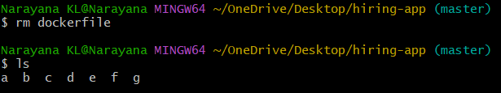
Step 2: to delete from github or to sync local and central
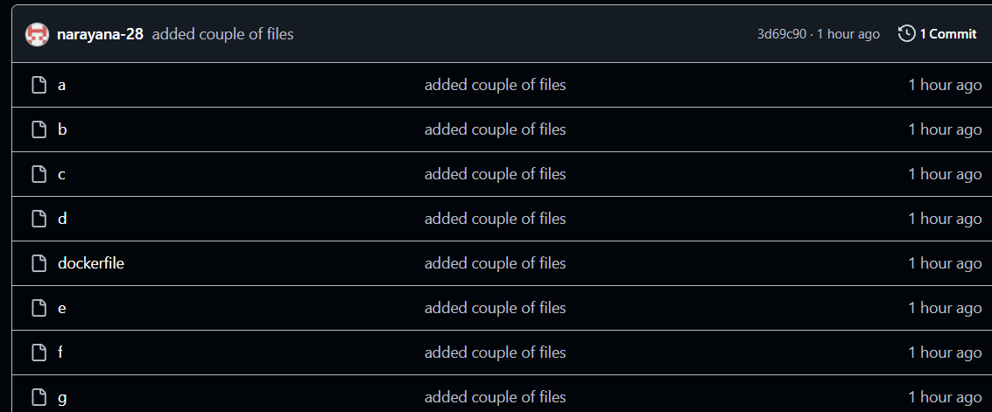
Input
Step 3: check status
Command : git status
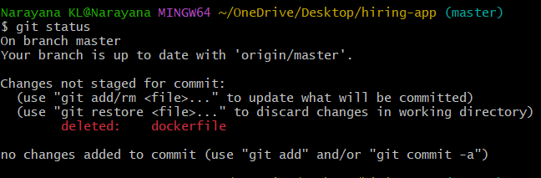
Step 4: update the changes
Command : git add .
Step 5: commit the changes
Command : git commit -m “deleted dockerfile”
Step 6: push all changes to central repository
Command : git push -u origin main
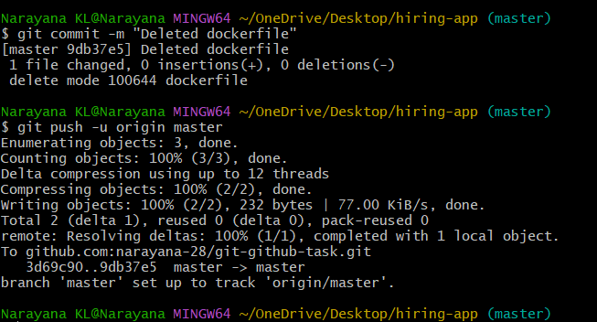

Go to github and refresh
Dockerfile deleted
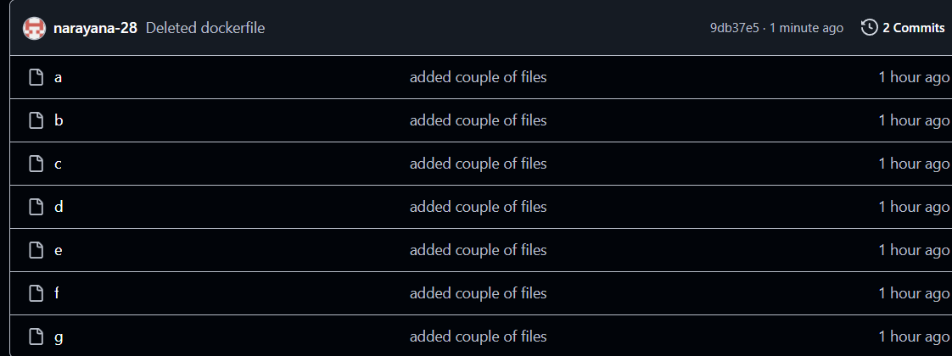
Scenario 2: If a file is created in GitHub, it will not appear in the local system until you pull
the latest changes.
Step 1: create file in github
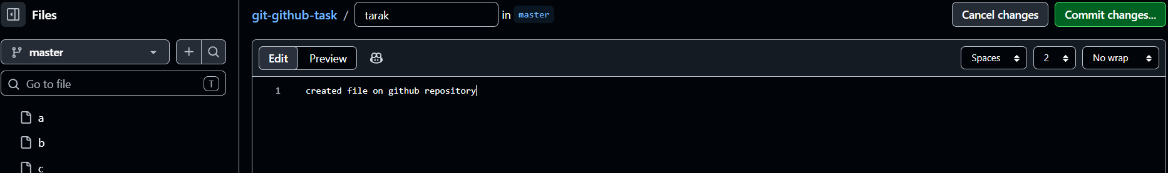
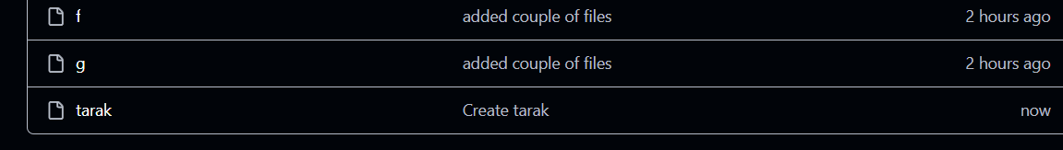
Step 2: create file in local system
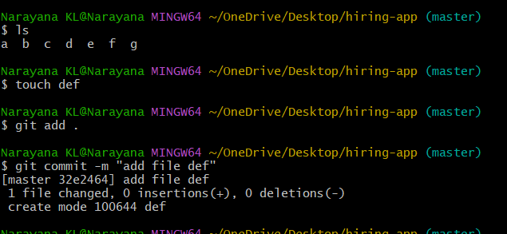
now if want to push the files it will through error because local and central repositories are
not sync

command : git push -u origin main
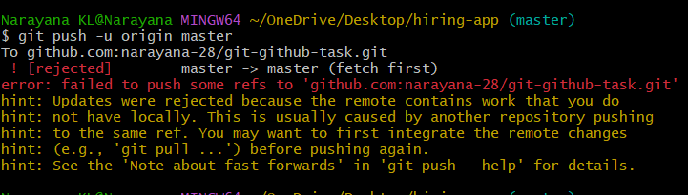
Step 3: central to local we need pull file
Command : git pull
Command : ls
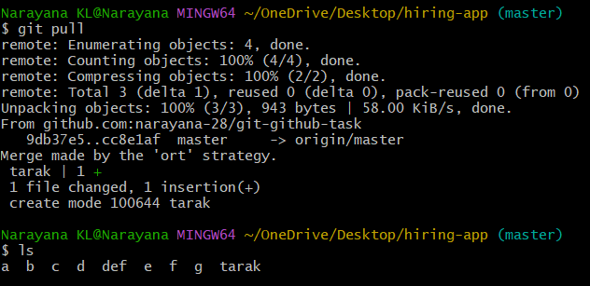
Now we can see tarak file in local machine
Step 4 : now push changes will be push to local to central
Command : git push -u origin main
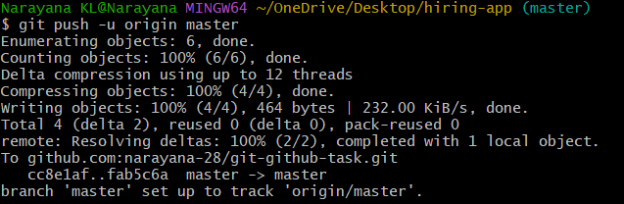
Local file def added and central repo file able to see in local
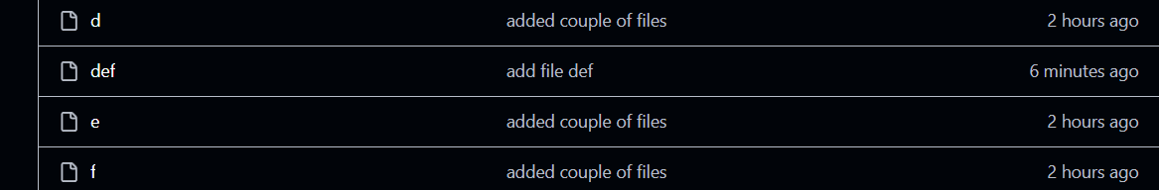
Git clone
Help us to download the source code form central to local
Command : git clone git@github.com:narayana-28/git-github-task.git
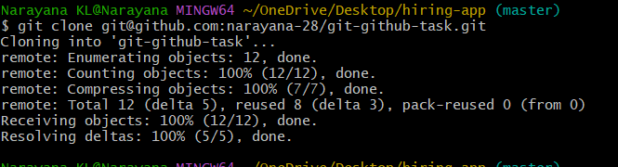
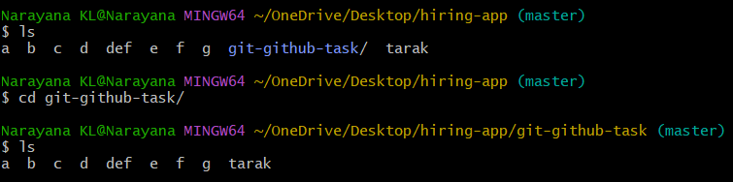
Scenario : if the directory deleted from local system how to download from central repo
Command : git clone
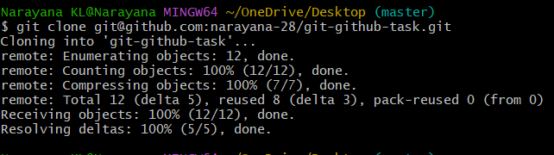
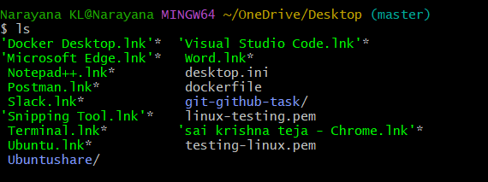

Scenario : how to retrieve deleted file
Command : git revert <commit id>
To know commit id we need run git log
Command : git log -4
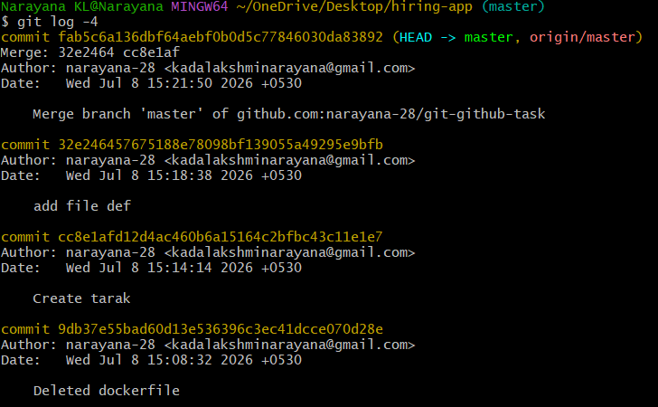Now run
Command : git revert <commit id>
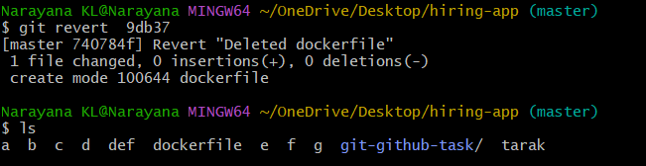
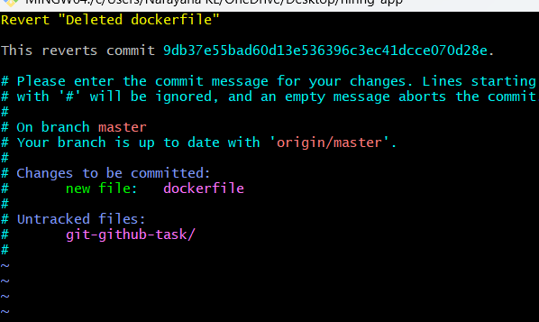
Dockerfile has been revert
How to change track file to untrack file
Command : touch samplefile
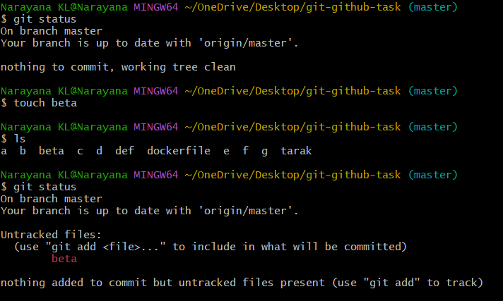
Command : git add .
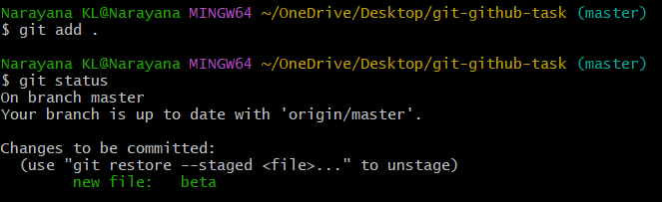
Now move to untrack
Command : git reset
